ALGORITHM
Step 1: Start
Step 2: Input integer n
Step 3: If n < 0
Print "Invalid Input" and Stop
Step 4: Set fact ← 1
Step 5: Set i ← 1
Step 6: While i ≤ n
fact ← fact × i
i ← i + 1
Step 7: Print fact
Step 8: Stop

6.1.2 FACTORIAL OF A NUMBER

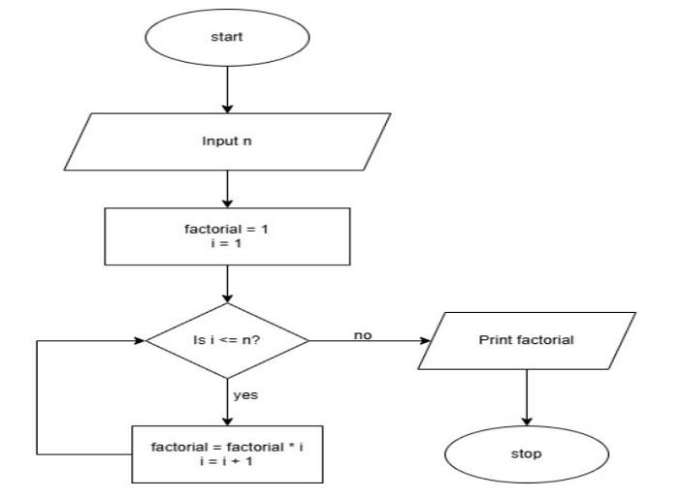

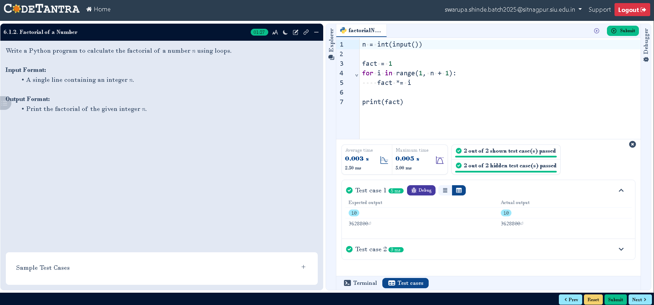
CODETANTRA:-

